Abu Rayhon Beruniy nomidagi
urganch davlat universiteti Kompyuter injinering fakulteti Kompyuter ilmlari va dasturlash texnologiyalari
234- guruh talabasi Odomboyeva Muhayyoning
“Machine learning” fanidan
6-laboratoriya ishi



O’qituvchi:Qurbonova Ruzikajon

Mavzu: Punduz(double underscore)

https://www.kaggle.com/datasets/amulyas/penguin-size-dataset?resource=download shu silka orqali kirib
Global Supply Chain Risk & Logistics (2024-2026) mana shuni csv faylini yuklab oldim
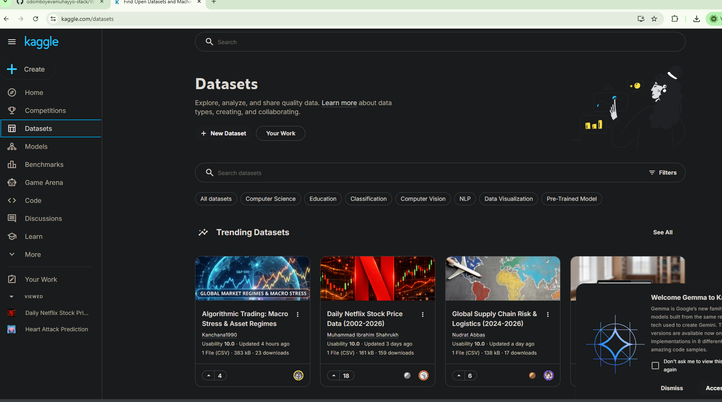
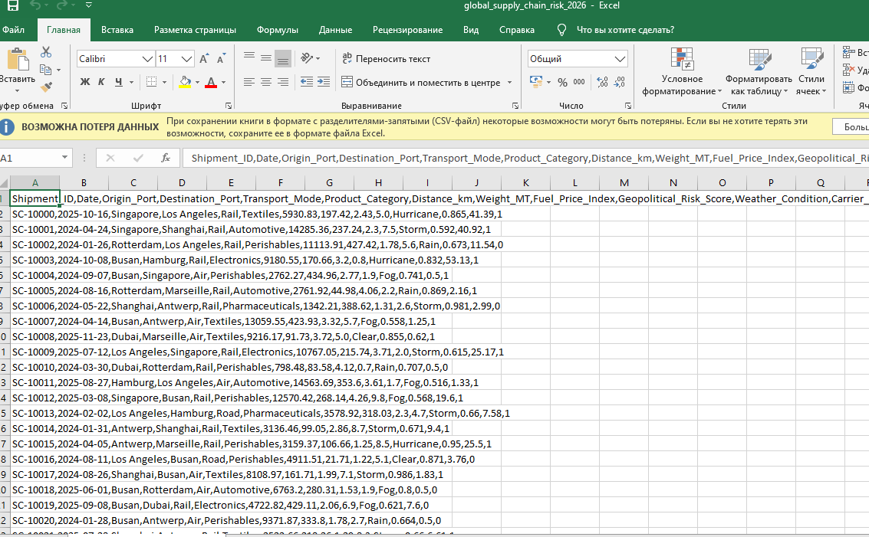
Kod qismi
import numpy as np
import matplotlib.pyplot as plt
from sklearn.datasets import make_classification
from sklearn.model_selection import train_test_split
from sklearn.neighbors import KNeighborsClassifier
from sklearn.metrics import accuracy_score

# 1. Misol uchun ma'lumot yaratish
X, y = make_classification(n_samples=100, n_features=2,
n_informative=2, n_redundant=0,
n_clusters_per_class=1, random_state=42)

# 2. Train va Test ga ajratish
X_train, X_test, y_train, y_test = train_test_split(X, y,
test_size=0.3,
random_state=42)

# 3. KNN modelini yaratish
k = 5 # KNN uchun qo'shnilar soni
knn = KNeighborsClassifier(n_neighbors=k)
knn.fit(X_train, y_train)

# 4. Har bir test instance uchun prognoz qilish
y_pred = knn.predict(X_test)

# 5. Natijalarni grafik bilan ko'rsatish
plt.figure(figsize=(8,6))

# Train punktlarini ko'rsatish
plt.scatter(X_train[:,0], X_train[:,1], c=y_train, marker='o', label='Train', edgecolor='k')

# Test punktlarini ko'rsatish
plt.scatter(X_test[:,0], X_test[:,1], c=y_pred, marker='s', label='Test predictions', edgecolor='k')

plt.title(f'KNN (k={k}) bo\'yicha train va test instance grafiki')
plt.xlabel('Feature 1')
plt.ylabel('Feature 2')
plt.legend()
plt.show()

# 6. Test accuracy chiqarish
accuracy = accuracy_score(y_test, y_pred)
print(f"Test accuracy: {accuracy:.2f}")
